Customer Web Portal Mobile Assembly

Project Overview

Client seeks to leverage a customer care portal that will attract, engage, convert and retain customers to increase top line revenue growth. Through the use of customization and personalization, Client will engage its customers by allowing them to quickly locate the information they need. Client is certain that improving access to information, demonstrating thought leadership in its online offering of analytical data and improving customer care will increase the likelihood that a customer will return to the site and continue to do business.

This project develops a mobile version of the site using HTML5 and JavaScript technologies.

Requirements

Section 2.1 and 2.2 describe in brief the technical aspects of using backbone.js and bootstrap libraries. See ADS for the rationale behind using these libraries.

backbone can be a little complicated to start with but later becomes quite intuitive. The best place to start backbone are the 5 beginner tutorials at http://backbonetutorials.com/ and the 5 samples at http://arturadib.com/hello-backbonejs/docs/1.html

bootstrap is very very intuitive and their website is the best place to visit http://getbootstrap.com/getting-started/

Backbone MVC Usage

We will use backbone.js MVC standards for developing the mobile website. In a backbone.js based system, the code is divided into Model, Views and Routers. It is similar to standard MVC and is the purposes of the various layers is described below:

Model – The entity model and the calls to the persistence (in our case the REST API). At no time should the model ever access any UI elements or even call the View or Router.
View – Displays the UI, calls the model to get the data and listens to changes to the model to update the display. It is heavier than the usual MVC View in the sense that it calls the persistence via Model instead of the Controller doing so.
Router – A lightweight version of the MVC Controller. Here it is only responsible for calling the appropriate view in response to changes in the URL. The Router should simply initiate a view based on the URL and typically must not do anything else.

Templating
The main View for a page will be divided into various sub-views. Each sub-view will be responsible for rendering itself. The views will take advantage of the backbone templating system, which are simply HTML snippets with placeholder variables. This is very similar to the C# partial views (.cshtml) files that are being used in the desktop version. For example, here is a sample template with one textbox and a button. The initial value of the textbox is a template variable:
<script type="text/template" id="search_template">
<input type="text" id="search_input" value="<%= init_val %>" />
<input type="button" id="search_button" value="Search" />
</script>

The template can be loaded and the variable replaced with actual value, with the following code:

//Pass variables in using Underscore.js Templatle
var variables = { init_val: "Enter Your Name" };
// The template variable now contains the html for the template with the variables set
var template = _.template( $("#search_template").html(), variables );

Router
The backbone router is used to define the mapping between url and the function that handles that url. The URLs are relative to the hashtag of the URL.

var AppRouter = Backbone.Router.extend({
routes: {
"/home": "recentSamplesRoute",
"/recentResults": "recentResultsRoute",
"/login": "loginRoute".....etc
}
});
// Instantiate the router
var app_router = new AppRouter();
app_router.on('route:recentSamplesRoute', function () {
// Create the RecentSamplesView here and call the render on it
});
app_router.on('route:loginRoute', function () {
// Create the LoginView here and call the render on it
});
// Start Backbone history a necessary step for bookmarkable URL's
Backbone.history.start();

Bootstrap Usage

Bootstrap provides flexible responsive grids which change size according to the target device. The grid is divided into 12 parts and each row can be split into columns independently. See here for more details http://getbootstrap.com/css/#grid
We will use both the .col-xs- and the .col-sm- class prefixes as we deal with phones and tablets respectively.

Forms will be created as per the guidelines at http://getbootstrap.com/css/#forms and buttons will be created as per the guidelines at http://getbootstrap.com/css/#buttons

For modal pages we will use Bootstrap modal http://getbootstrap.com/javascript/#modals

For date picker we will use http://www.eyecon.ro/bootstrap-datepicker/

Recent Samples View

This page will use the SearchAnalysis REST call to populate its data and to perform further search.
The page will be displayed using the RecentSamplesView. The page will be divided into 4 sections each of which will loaded using a template.
- Header (common for all pages)
- Search Section
- Results Section
- Paging Controls

The Search Section will simply be static html snippet for the following UI:

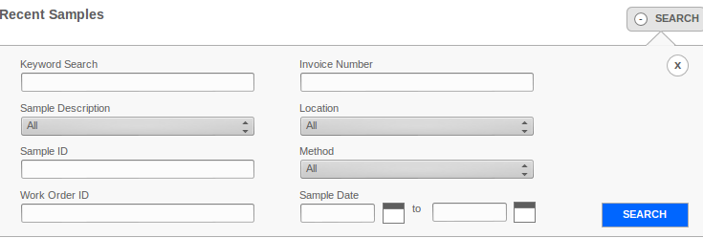
The Results Section will first show the table header like so:

After this each row will itself be a table and will be displayed using the SamplesByProjectView.

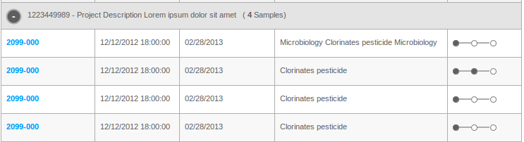
On clicking the sample link we will show a modal to show the sample details. We already have all the data needed to display the modal, so no further REST call will be made.

Finally we will have the paging controls as shown below:

Recent Results View

This page will use the SearchAnalysisResults REST call to populate its data and to perform further search.
The page will be displayed using the RecentResultsView. The page is also divided into 4 sections like the Recent Samples page. It is just an easier version because the Search Results are a simple table instead of a nested table.

Sample Details View

On clicking the Sample link, we will display all the Sample Results in a modal. We will need to make an extra call to the GetAnalysis REST method. The SampleDetailsView will be responsible for creating the modal in the DOM and the RecentResultsView will be responsible for attaching the modal to the DOM and displaying it.

Most of the content of the modal is straight forward mapping from the SampleDetailAnalysis object to the UI fields. The graphical display of each SampleDetailAnalysis.Result (see image below) is somewhat more complex but the logic is already present in existing code's sample_details.cshtml lines 87-148. This code simply needs to be converted to JavaScript

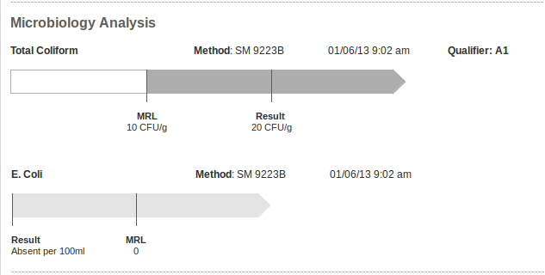

Method Detail View
On clicking the Method link, we will display all the Method Description in a modal. We will need to make an extra call to the GetMethodDetail REST method. The MethodDetailsView will be responsible for creating the modal in the DOM and the RecentResultsView will be responsible for attaching the modal to the DOM and displaying it.

Export Analysis Link
The last column of the table will be a link to export the Sample. The link must directly be set to the FetchFile REST GET method URL (i.e. using the a href) with the raw parameter set to true and contentType set to application/pdf . The REST method will respond with the File in the HTTP response.

New Project and Sample Containers View

This page will use the SendNewProjectRequest and SendSampleContainerRequest REST call to save the new project and new sample containers data.

The page will be displayed using the NewProjectView and the SampleContainerView. Note that initially only the NewProjectView will be present in the DOM and the Sample Container view will be added to the DOM only if the Request Sample Container button is clicked.

The initial page will be divided into 2 sections each of which will loaded using a template.
- Header (common for all pages)
- New Project Section

Client Services Contact View

This page will use the GetProjectManagersOfUser REST call to show the project managers for the user. It will use the SendFeedback REST call to send feedback to the project manager.

The page will be displayed using the ClientServicesContactView. The modal view to send the feedback will be added to the DOM only if the Send button is clicked.

The initial page will be divided into 2 sections each of which will loaded using a template.
- Header (common for all pages)
- A table containing multiple rows where each row is the detail of the project manager (like so)
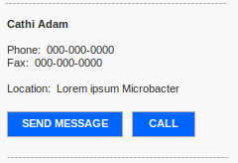

Login View

This page will use the AuthenticateUser REST call to login the user.

The page will be displayed using the LoginView.

The initial page will be divided into 2 sections each of which will loaded using a template.
- Header (common for all pages)
- The login template
- Other sections such as Forgot Password and Register (currently left to Final Fix)

Other Requirements

See ADS section 1.4 for cross cutting requirements like logging, configuration, exception handling, internationalization etc.

Fix the Registration Process

The Register logic in the code currently is incorrect and must be changed as required. The new registration process is as follows:

- It should not require the user to already exist in AD server
UserService.CreateUser has been changed to create a new user in AD rather than call UpdateAD as it does currently. See the TCUML documentation.
- When user submits registration form, an email will be sent to admin/PM
RegistrationController.Register has been changed to send email for notification of registration using the NotificationServiceClient. See the TCUML documentation.
- Admin/PM will decide if the account can be approved, if yes Admin/PM will manually add the user to AD server (using the user's email/password/etc from the registration form)
This step is external to our code
- The user should get a notification if the account is approved / rejected.
This step is external to our code

Technology Overview

Application Technologies

- IIS 7.0
- WCF REST Services
- HTML 5
- JSON
- jQuery 1.10.2
- backbone.js 1.0.0
- bootstrap 3.0

Project Dependencies

Assemblies
Existing WCF based REST services from the Desktop Version

Components
None

Third Party Libraries
See section 3.1

Project Deliverable Details

Source code setup
Standard TopCoder Assembly Contest source code setup

Build Setup
Standard TopCoder Assembly Contest ant based build setup

Final Submission
- For each member, the final submission should be uploaded to the Online Review Tool.
- The final submission will be reviewed using the standard Online Review Assembly Scorecard.

